NETFLIX
MOVIES & TV SHOWS
Exploratory Data Analysis — Project Report

Dataset: Netflix Titles (netflix_titles.csv)
8,807 titles · 12 attributes
Prepared: September 2026

1. Introduction
Netflix is one of the world's largest streaming platforms, offering thousands of movies and TV shows across genres, languages, and countries. This project performs an exploratory data analysis (EDA) on the public Netflix Titles dataset to uncover patterns in content type, genre, country of origin, ratings, and how the catalogue has grown over time.
The objective is to understand the composition of Netflix's content library and surface insights that could inform content strategy, such as which genres and regions are most represented, and how content acquisition has trended year over year.

2. Dataset Overview
The dataset contains the following fields:
Column | Description
show_id | Unique identifier for each title
type | Movie or TV Show
title | Name of the title
director | Director(s) of the title
cast | Main cast members
country | Country/countries of production
date_added | Date the title was added to Netflix
release_year | Year the title was originally released
rating | Content/age rating (e.g., TV-MA, PG-13)
duration | Runtime in minutes (movies) or seasons (TV shows)
listed_in | Genre(s)/category tags
description | Short synopsis of the title

Key dataset statistics:
Metric | Value
Total titles | 8,807
Movies | 6,131 (69.6%)
TV Shows | 2,676 (30.4%)
Release year range | 1925 – 2021
Titles added (dated) | 2008 – 2021
Distinct countries represented | 748 unique country combinations
Duplicate rows | 0

3. Data Cleaning
Before analysis, the following cleaning steps were applied:
- Parsed date_added into a proper datetime type and derived a year_added column.
- Missing values were found in director (2,634), cast (825), country (831), date_added (10) and rating (4) — these were treated as 'Unknown' rather than dropped, to avoid losing rows.
- For titles with multiple countries listed, the first listed country was used as the primary country of production.
- The listed_in genre field was split on commas to analyze individual genre tags, since many titles carry 2–3 genres.
- No duplicate rows were found in the dataset.

4. Exploratory Data Analysis

4.1 Content Type Distribution
Netflix's catalogue is dominated by movies, which make up just under 70% of all titles, while TV shows account for roughly 30%.
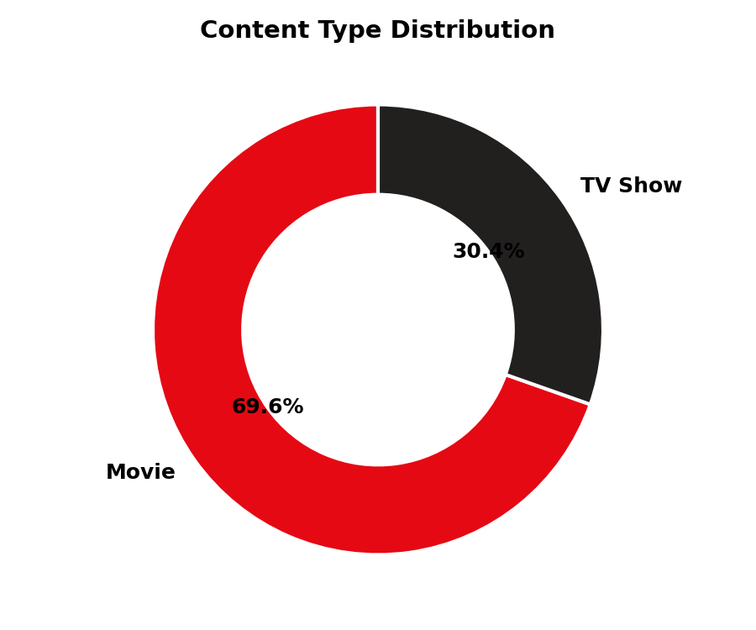
Figure 1: Proportion of Movies vs TV Shows in the catalogue

4.2 Catalogue Growth Over Time
The number of titles added to Netflix grew steadily from 2008 through 2019, before dipping slightly in 2020–2021 — plausibly linked to production slowdowns during the COVID-19 pandemic. 2019 was the peak year, with just over 2,000 new titles added.
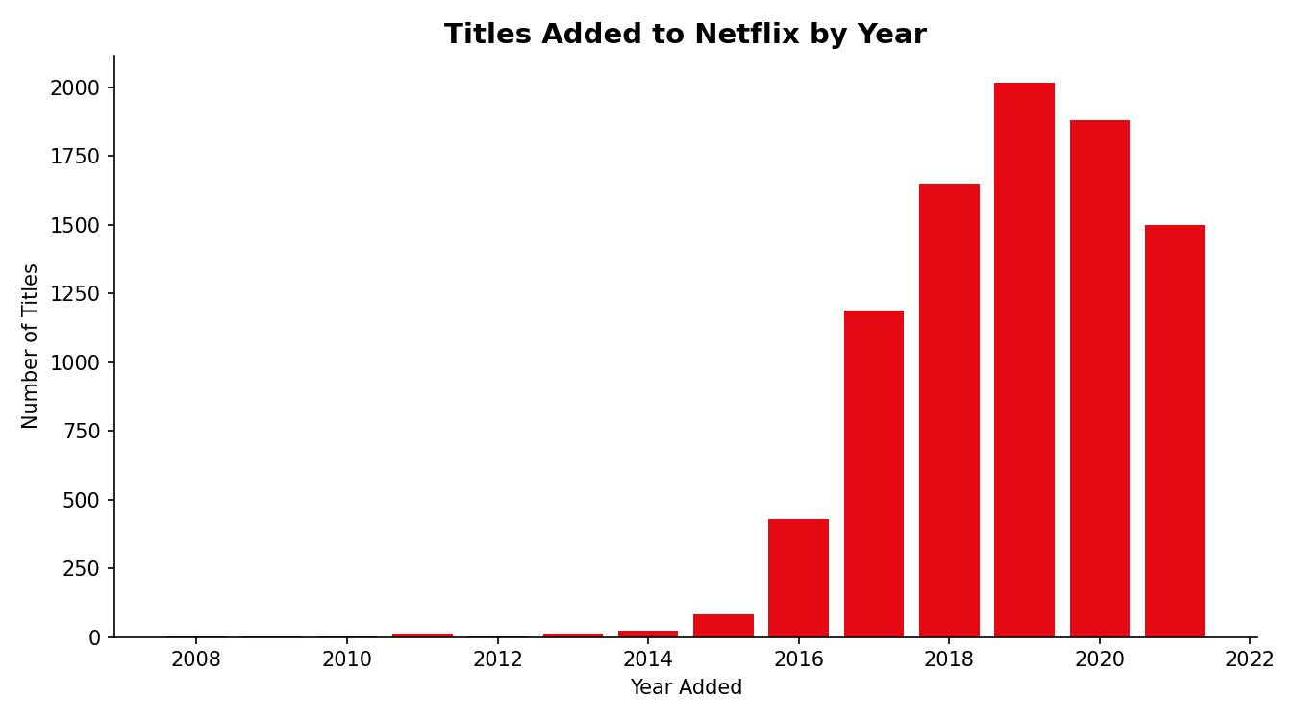
Figure 2: Number of titles added to Netflix, by year

4.3 Most Common Genres
International Movies, Dramas, and Comedies are the three largest genre categories. International content overall (International Movies + International TV Shows) represents a very large share of the catalogue, reflecting Netflix's global content strategy.
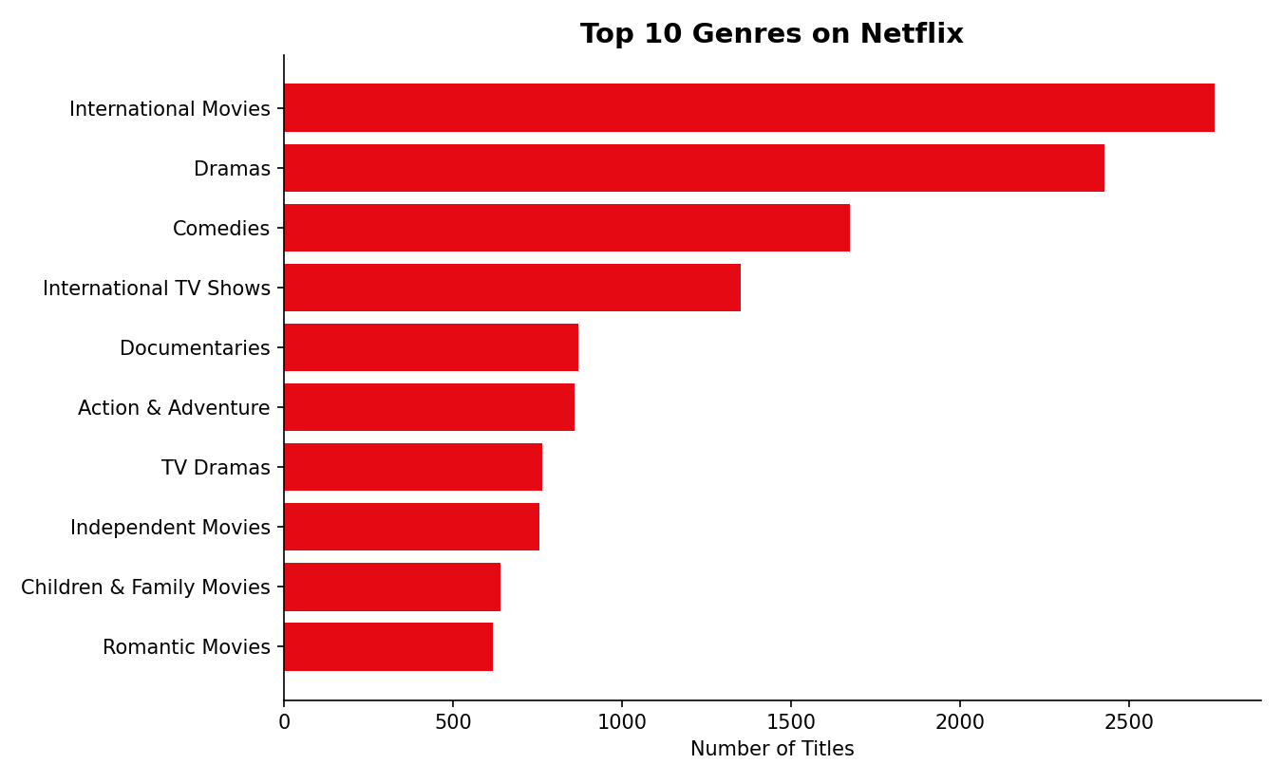
Figure 3: Top 10 genres by number of titles

4.4 Content by Country
The United States leads content production by a wide margin, followed by India and the United Kingdom. This reflects both Netflix's origins as a US company and its major investments in Indian regional content.
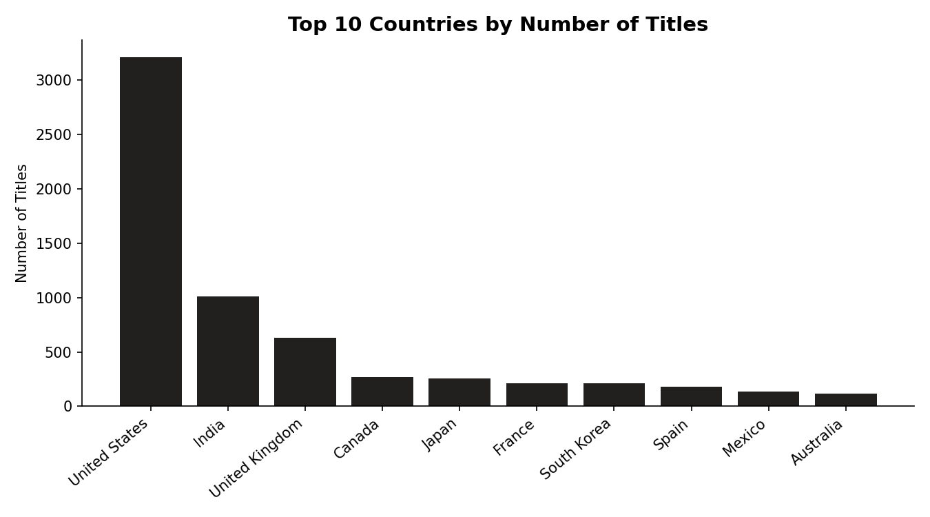
Figure 4: Top 10 countries by number of titles produced

4.5 Content Ratings
TV-MA (mature audiences) and TV-14 are the two most common ratings, together accounting for well over half of all titles — indicating that Netflix's catalogue skews toward adult and teen audiences rather than young children.
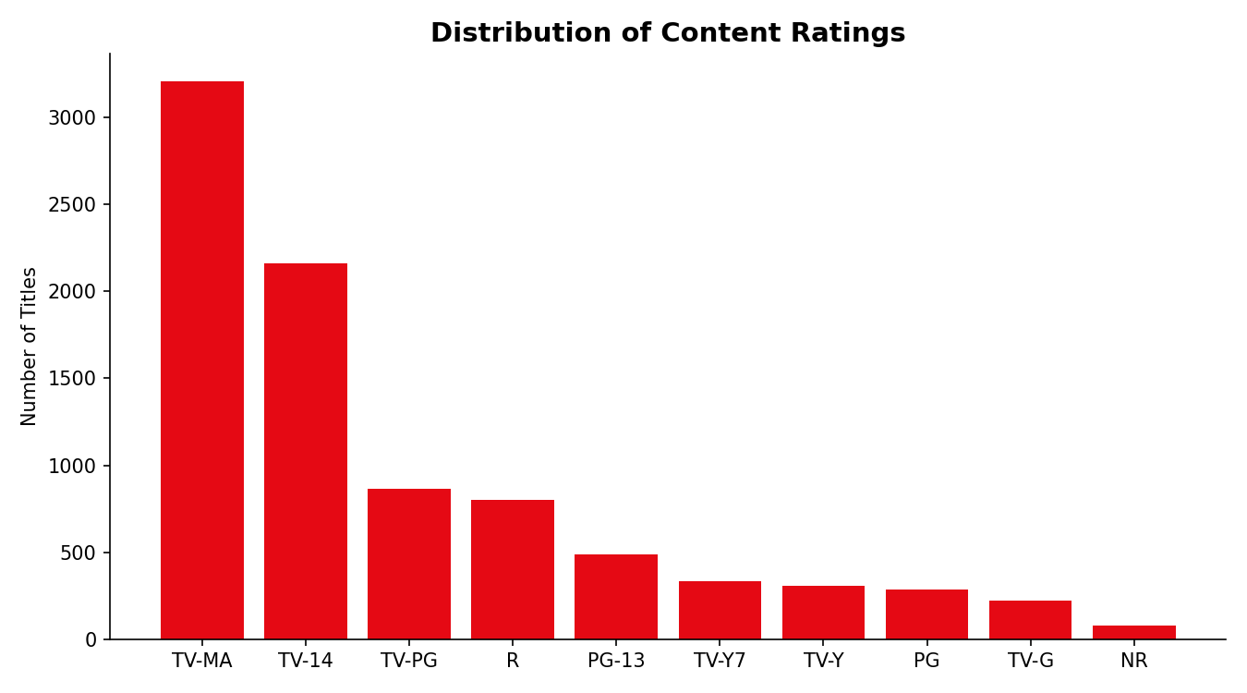
Figure 5: Distribution of content ratings

4.6 Release Year Trends: Movies vs TV Shows
Both movies and TV shows on the platform are heavily weighted toward recent releases (2015 onward), but movies show a longer tail of older titles reaching back several decades, while TV shows are more concentrated in the last 10–15 years.
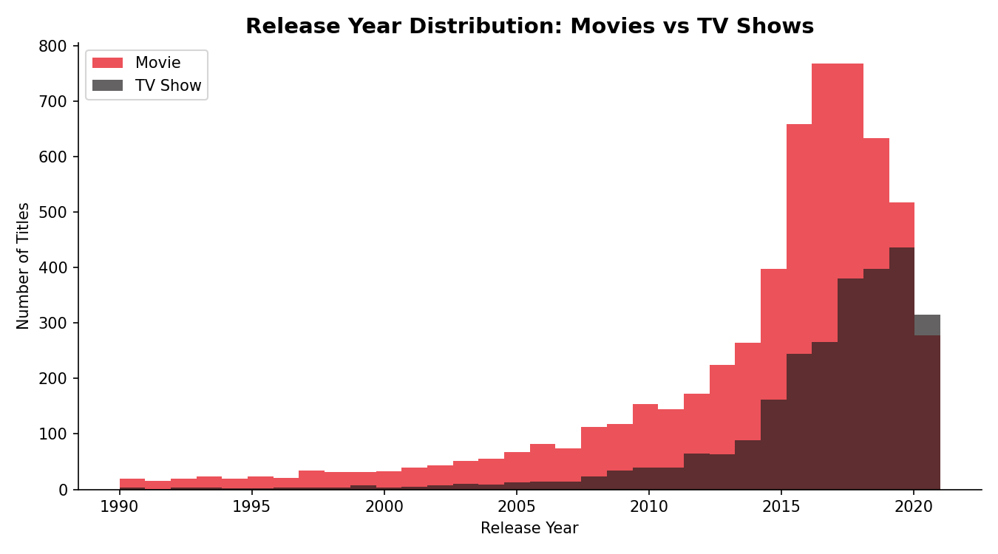
Figure 6: Release year distribution, Movies vs TV Shows (since 1990)

5. Key Insights
- Movies outnumber TV shows roughly 2.3 to 1 on the platform.
- Content acquisition accelerated sharply after 2015, peaking in 2019, then eased slightly in 2020–2021.
- International Movies is the single largest genre tag, ahead of Dramas and Comedies — underscoring Netflix's global-first content strategy.
- The US, India, and the UK together account for a large majority of production countries, with India standing out as the top non-US contributor.
- TV-MA and TV-14 ratings dominate, suggesting the catalogue is oriented toward teen and adult viewers over young children's content.
- Older titles (pre-1990) exist mostly among movies, while TV shows are almost entirely a post-2000 phenomenon on the platform.

6. Limitations
- The dataset is a snapshot (as of 2021) and does not reflect Netflix's current catalogue.
- Country, director, and cast fields have missing values, which were treated as 'Unknown' rather than imputed, so regional and personnel-based analysis is only partial.
- Only the first listed country was used for country-level analysis, which slightly understates co-production countries.
- Duration mixes two different units (minutes for movies, seasons for TV shows) so it could not be directly compared across content types.

7. Conclusion
This EDA of the Netflix Titles dataset highlights a catalogue that is movie-heavy, increasingly international, and oriented toward mature audiences. Content growth accelerated significantly between 2016 and 2019 before leveling off. These patterns offer a useful baseline for further analysis, such as genre-level trends within specific countries or predictive modelling of content popularity.

